**MESD Documentation LMS-97-Single-Sign-On**

**Purpose**

To allow for users to sign in to their Moodle account through the 1Gov Portal facilitated through Single Sign On (SSO).

**Background**

The MESD LMS will be hosted and housed by the 1Gov 1Citizen platform. This initiative exists to provide services to provide residents of Botswana in a more efficient and effective manner. The MESD LMS will be a service that will be available through this portal and thus arises the necessity for authorization of users to be facilitated through the 1Gov 1Citizen platform.

SSO is accomplished by 3 main components in our solution we followed Moodle’s best practices and created plugins where needed.

**Redirect Module**

The redirect module is a Restful API which redirects incoming users from the 1Gov 1Citizen platform and sends them to the correct instance of Moodle their institution is running on. Only 1Gov 1Citizen Platform IP addresses will be white listed to access the Redirect Module API.

**User Addition API Plugin**

This Moodle plugin updates the redirect modules database of users and where they are registered too. The source code for this plugin can be found in the local folder of Moodle.

**Auto Login Plugin**

This plugin makes use of SHA256 Hashing to securely sign users who were redirected from the Redirect Module into their school. The source code for this plugin can be found in the local folder of Moodle.

**Setup Process**

**Disable Email-based self-registration**

Navigate to Site Administration -> Plugins -> Authentication Plugins -> Manage Authentication

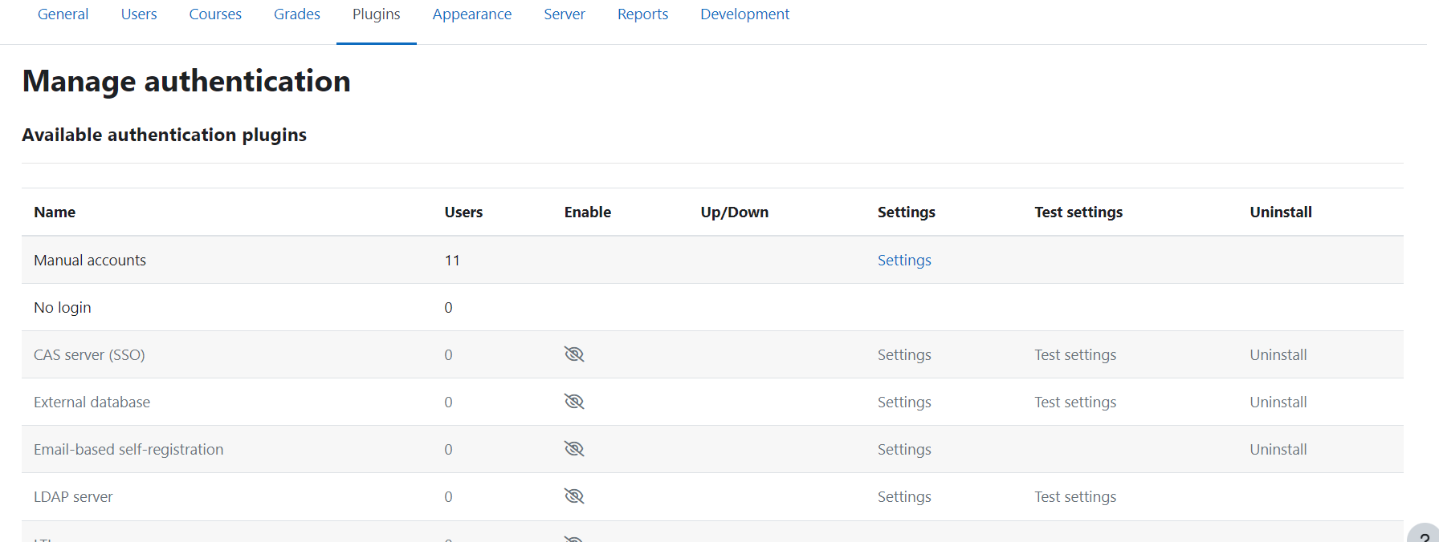

Ensure Email-based self-registration is disabled by pressing the eye icon.

**SSO Related Plugins**

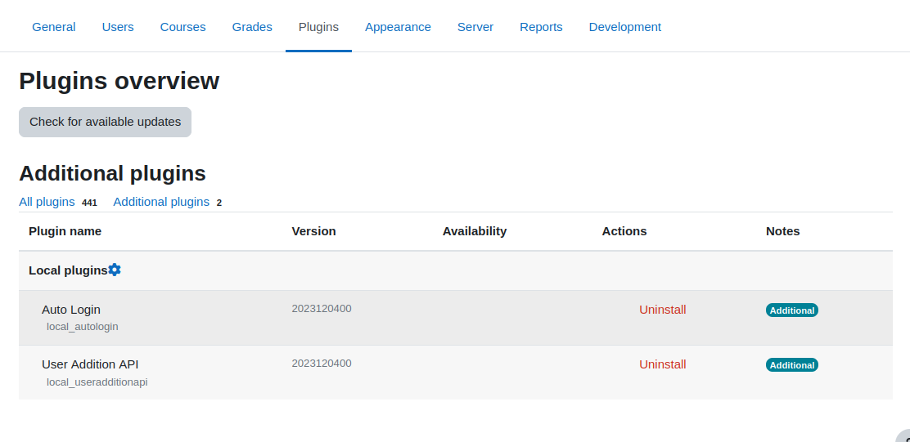

Ensure the SSO related plugins are installed at Site Administration -> Plugins -> Plugin Overview -> Additional plugins. If they are not installed go to the notifications section of Moodle and look for pending plugin installations.